Please use the framework below to systematically test a workitem report.

You will need:
a) access to ediProduction system for locating workitems
b) network access to the report testing database.
c) a copy of the Report Feedback document that you will attach to the workitem

Questions about Testing:
Contact Terri Bowen (terri.bowen@edi.com.au) with any questions about which workitem to test, how to test a specific report, or the purpose of a specific report.

Exceptions or Database access problems:
Contact Paul Wahltuch (paul.wahltuch@edi.com.au) who will address any database / exception / report problems

TESTING INSTRUCTIONS - REPORTS

1. Open the report workitem you have been assigned/selected
On the workitem you will find a Report Specification that identifies the filters, a sample layout, and purpose of the report.
Use this specification as a guideline when testing the report.

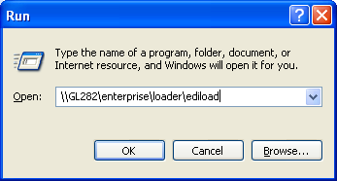
2. Open the report testing database
To run ediEnterprise for report testing you need to
a) Connect to the Sydney VPN
Then
b) open the test database by copying \\GL282\enterprise\loader\ediload into your
Start->Run dialogue box.

3. Report Feedback document
Use the Report Feedback Document to systematically test a report.

- Please test the report systematically, and ensure that your comments are clear.
- Please identify what Does Work, and
- Please identify (provide examples if possible) what Does Not Work
- Please identify what you DID NOT test / check so that others can pick up where you left off.
- Please use the following framework to provide clear feedback so that we do not end up doubling up.

4. Attach your Feedback document to the Workitem
Attach your feedback to the eDocs tab of the relevant workitem, and let Terri Bowen and Paul Wahltuch know.
Use the FRF – Functional Review Feedback document type when attaching your document to the workitem.

WHICH WORKITEMS TO TEST
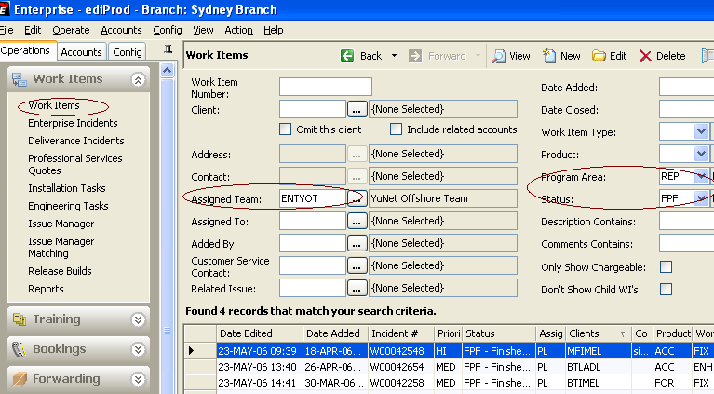
If you have not been asked to test a specific workitem you can locate a Report testing task yourself through ediProd’s Operations > Workitems search grid.

Report development tasks ready for testing
can be found in ediProd’s Workitems module by filtering for:

Assigned Team: ENTREP or ENTYOT (report development is done by two teams)
Program Area: REP (reports)
Status: FPF (finished pending functional review)

Reports ready for testing have a Status type FPF (finished pending functional review)

To ensure there is no double up - let both Terri Bowen and Paul Wahltuch know which workitem you are testing.

REPORT FEEDBACK DOCUMENT - Instructions

WORKITEM | W00014211
Testing DATE | 25 MAY 06
Tested by | Terri Bowen

REPORT NAME | Name of report being tested

General Testing Comment | Enter in a General Comment.

FILTERS
Confirm that all filters are working correctly
Identify any problems.
Please test each filter independently and confirm if it is working.
If there is a problem, please make a note identifying the behaviour you are seeing.
If possible, please provide a specific record for reference (eg. Shipment, consol, job, transaction etc)
Where a report uses “Optional Templates” you need to ensure filters work appropriately for each layout, as each “optional template” will create a separate query.

Example.
Status | FILTER | Comments
Problem | PERIOD | refer DATA issue below  otherwise this filter works correctly.
Change Behaviour | TRANSACTION TYPE | Make this a mandatory filter.  At least one transaction type must be ticked.  The actual filter is working perfectly. Just make it mandatory
Works | Exclude gst/vat | Fully tested

DATA
Identify any Data Problems
Within the body of a report there is always some form of detailed information listed.
Please ensure the full range of possible data types are tested.
Please check that information is correctly displaying in each column
Make clear comments confirming what is displaying correctly.
Make clear comments / provide examples if there are any problems.

Example.
Status | DATA | Comments
Problem | PERIOD DATE Ranges | Problem - Period Date Ranges – 24 hour problem with end date calculation.  Each Period range is MISSING any transaction posted on the last date of each period. eg. Period ends 31 March… transactions posted on 31st march are not being included
works | All other Results | All checked & working

REPORT SORT ORDERS
Confirm that Sort orders in the Report are working correctly.
Identify any problems.
Check that data listed in the report is sorting appropriately.
Make clear comments confirming if the sort orders are correct.
Make clear comments/provide examples if there are any problems.
Example.
Status | SORT | Comments
Change Behaviour | Sales in Period | Amend to Sort by Sales In Period (descending order), THEN Organisation (ascending order).  This will mean that there will be a proper sort order when organisations have the same “sales” amount.
Works | Organisation Code | Tested & Working correctly
REPORT GROUP BYS
Confirm that Grouping in the Report is working correctly.
Identify any problems.
GroupBy is used to “Group related records together under a single heading”.
The Grouping can include counts & subtotals.
Make clear comments confirming groupbys that work
Make clear comments / provide examples if there are any problems

Example.
Status | GROUP BY | Comments
Problem | Consolidation Category | Is not pickup up customised categories from registry
Works | Accounts Relationship | Fully tested & working

SUBTOTALS & TOTALS
Confirm that Totalling in the Report is working correctly.
Identify any problems
Check that any Totals, Subtotals are displaying correctly.

Example.
Status | TOTALS | Comments
Format Problem | Month Totals | Formatted wrongly. Needs to be to two decimal places
Works | Grand Totals | Tested & working correctly

LAYOUT/s
Check and confirm layout is correct for each OPTIONAL TEMPLATE
Identify any problems
Please check headings, columns, autoheight (if appropriate), eg.
Make clear comments.
Where a report uses “Optional Templates” you need to test each layout separately as they are completely separate queries and excel template layouts.
If changes are required please
1) save a sample of the report as it currently generates
AND
2) HIGHLIGHT the problem areas in the file.
3) Make appropriate notes in your email.

Example.
LAYOUT 1
Status | LAYOUT FEATURE | Comments
PROBLEM | Report Titles  Are Report Headings/titles displaying correctly? | Report Heading & Title  - Remove solid BLACK line from above report  - Company Name should be a MACRO. Currently incorrectly Hard coded in the template.  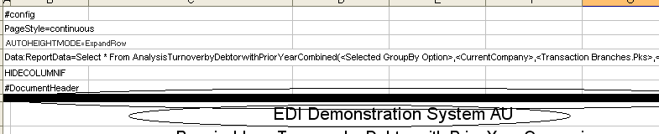
Correct | Margin, scaling & orientation.  Is the Excel Page Setup correct? | Checked & correct

